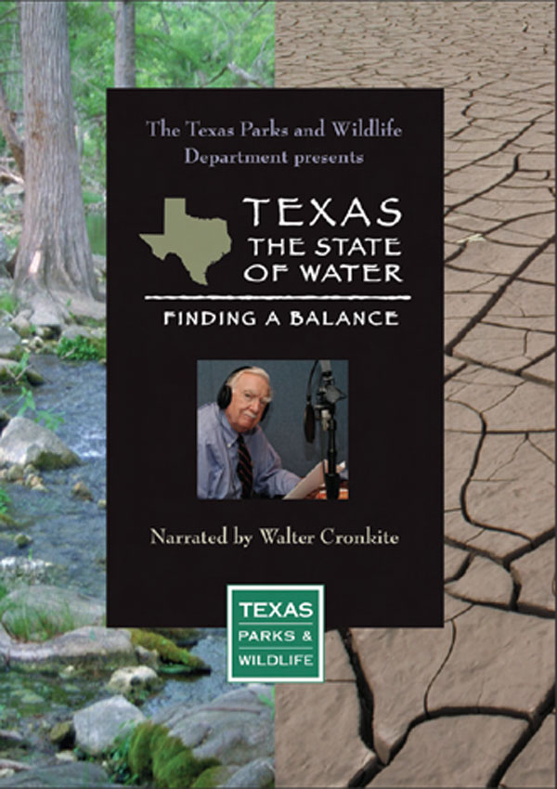 | Finding a  Balance
 | Join us to watch, Texas Parks and Wildlife’s Finding a Balance. This one-hour documentary explores how the growing demand for water will grow dramatically over years to come, and weighs the impact that growth will have on the state. The documentary shows how the steps we take, or don’t take, will impact Texas and its people, wildlife and economic vitality for future generations.
 | ENTER DATE

Enter event location
and time here

FOR MORE INFORMATION
Enter contact person or organization
Phone and/or email

[insert logo in this cell, or replace text  with sponsor name, if needed.] | 