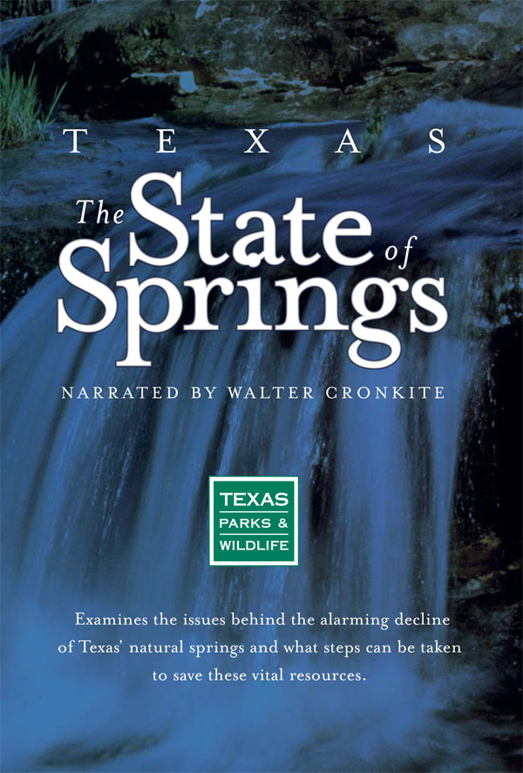 | The State  of Springs
 | Join us to watch Texas Parks and Wildlife’s The State of Springs. Narrated by Walter Cronkite, the documentary investigates the alarming decline of Texas’ natural springs and addresses the current issues that directly impact spring flow and what can be done to save these vital natural resources.
 | ENTER DATE

Enter event location
and time here

FOR MORE INFORMATION
Enter contact person or organization
Phone and/or email

[insert logo in this cell, or replace text  with sponsor name, if needed.] | 

